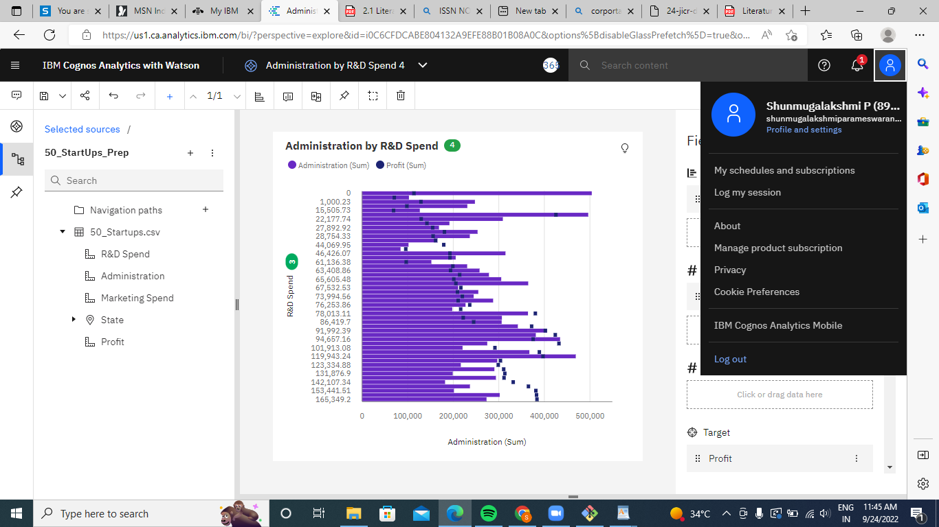

<https://us1.ca.analytics.ibm.com/bi/?perspective=explore&pathRef=.my_folders%2FAdministration%2Bby%2BR%2526D%2BSpend%2B4&subView=model000001836e22483a_00000002>  
  
  
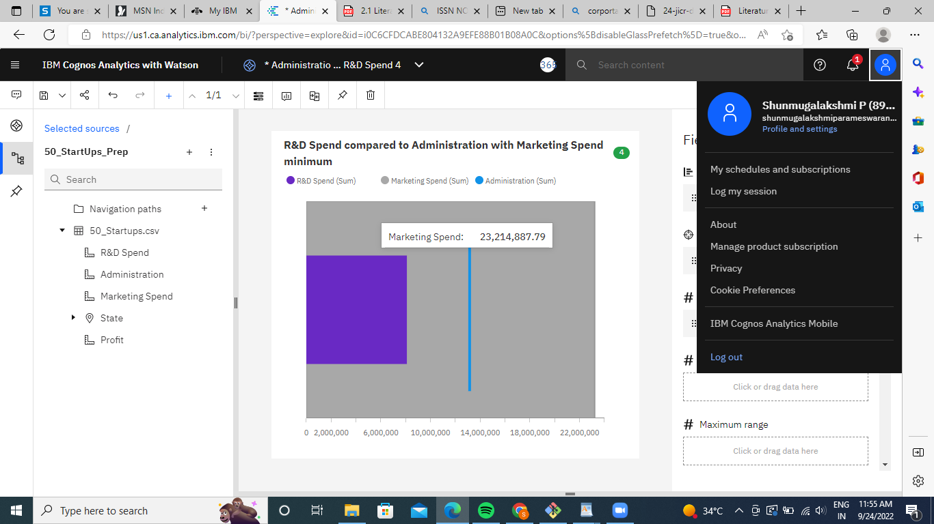

<https://us1.ca.analytics.ibm.com/bi/?perspective=explore&pathRef=.my_folders%2FAdministration%2Bby%2BR%2526D%2BSpend%2B4&subView=model000001836e22483a_00000002>

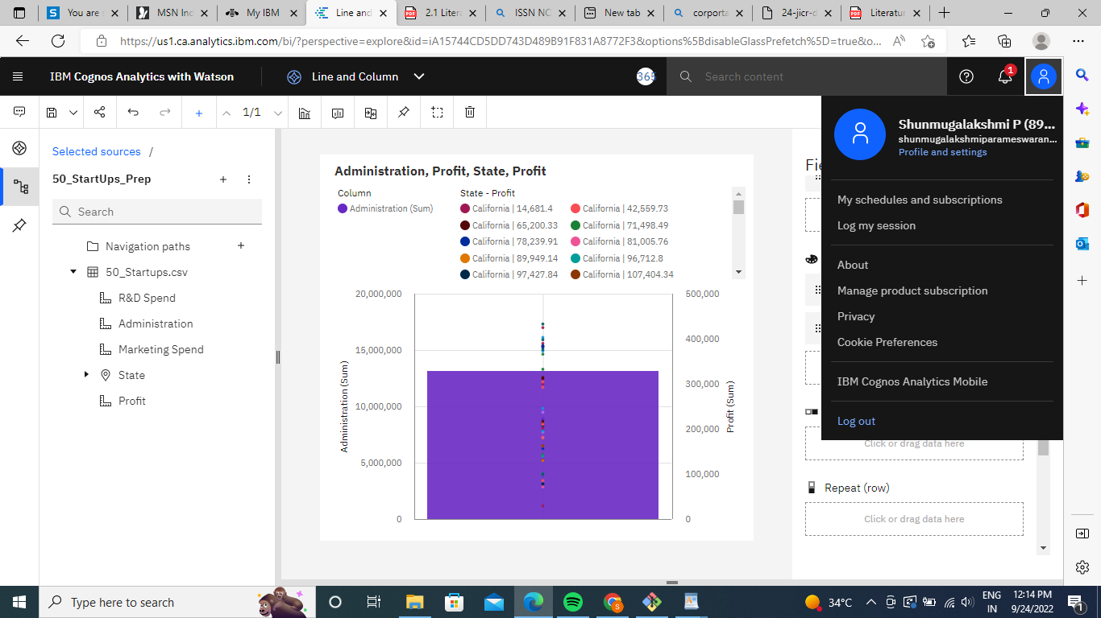

<https://us1.ca.analytics.ibm.com/bi/?perspective=explore&pathRef=.my_folders%2FLine%2Band%2BColumn&subView=model000001836e389ff7_00000000>

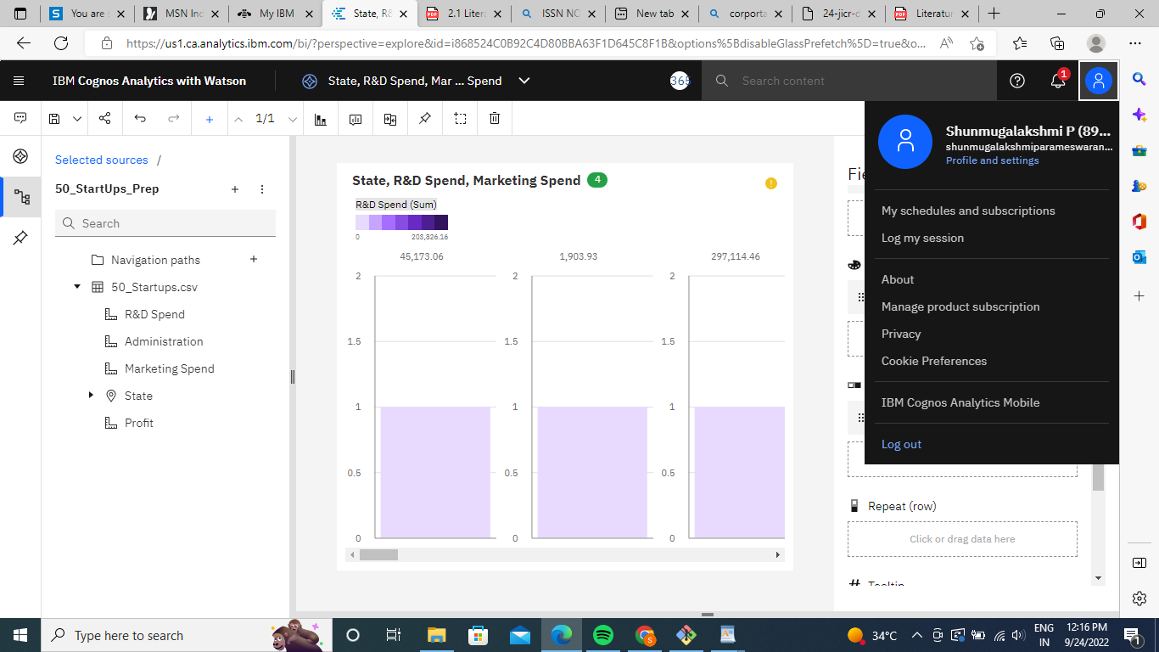

<https://us1.ca.analytics.ibm.com/bi/?perspective=explore&pathRef=.my_folders%2FState%252C%2BR%2526D%2BSpend%252C%2BMarketing%2BSpend&subView=model000001836e389ff7_00000000>   
  
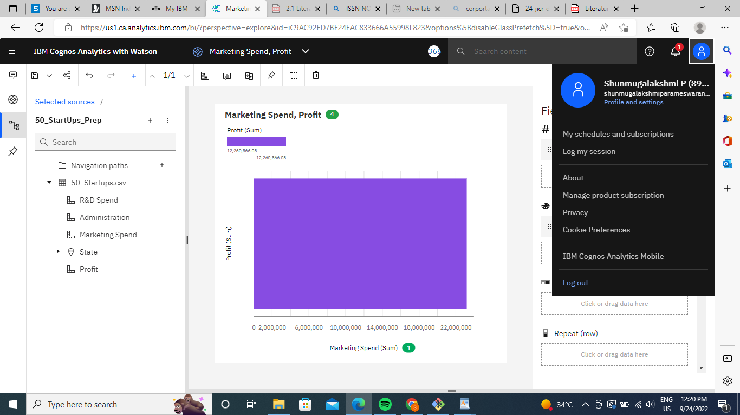

<https://us1.ca.analytics.ibm.com/bi/?perspective=explore&pathRef=.my_folders%2FMarketing%2BSpend%252C%2BProfit&subView=model000001836e4264d3_00000004>   
  
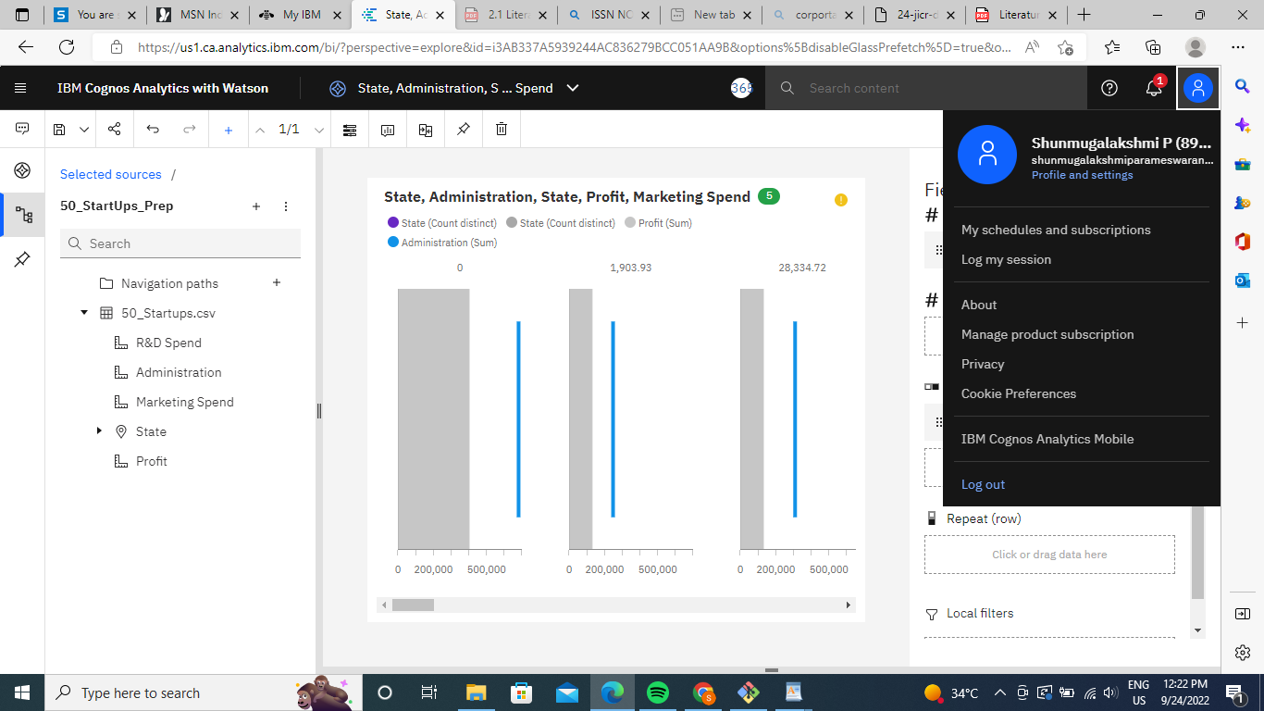

<https://us1.ca.analytics.ibm.com/bi/?perspective=explore&pathRef=.my_folders%2FState%252C%2BAdministration%252C%2BState%252C%2BProfit%252C%2BMarketing%2BSpend&subView=model000001836e4264d3_00000004>

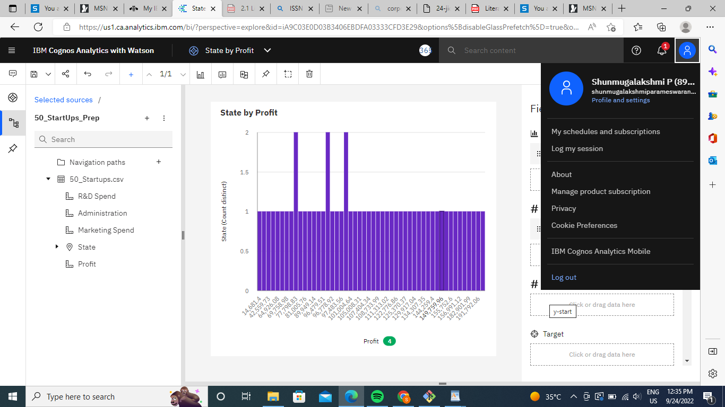  
  
<https://us1.ca.analytics.ibm.com/bi/?perspective=explore&pathRef=.my_folders%2FState%2Bby%2BProfit&subView=model000001836e4b9899_00000004>   
  
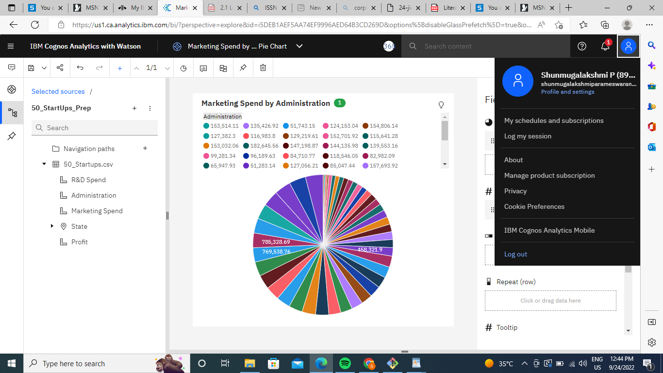   
<https://us1.ca.analytics.ibm.com/bi/?perspective=explore&pathRef=.my_folders%2FMarketing%2BSpend%2Bby%2BAdministration%2BPie%2BChart&subView=model000001836e57231c_00000000>

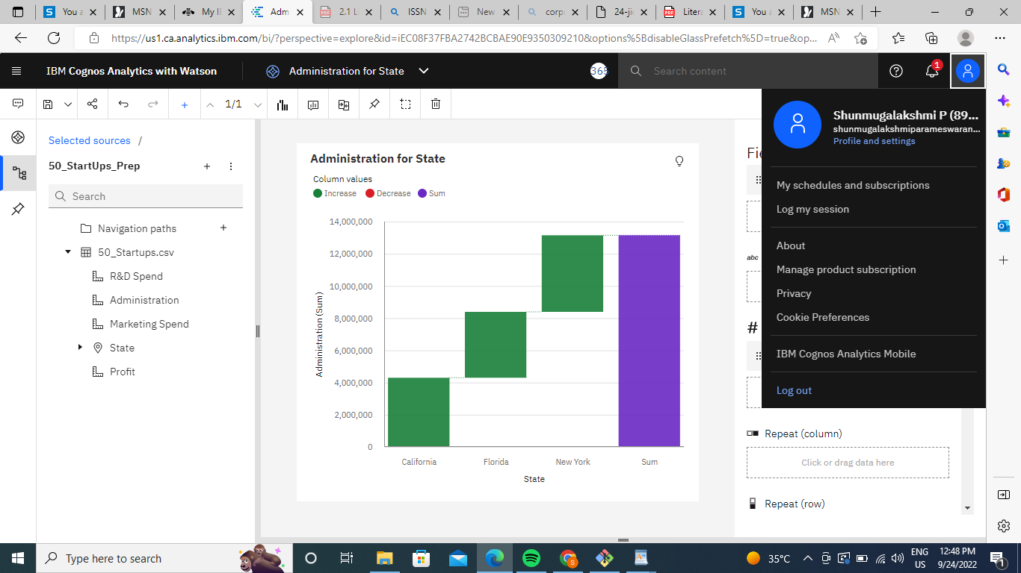

<https://us1.ca.analytics.ibm.com/bi/?perspective=explore&pathRef=.my_folders%2FAdministration%2Bfor%2BState&subView=model000001836e57231c_00000000>

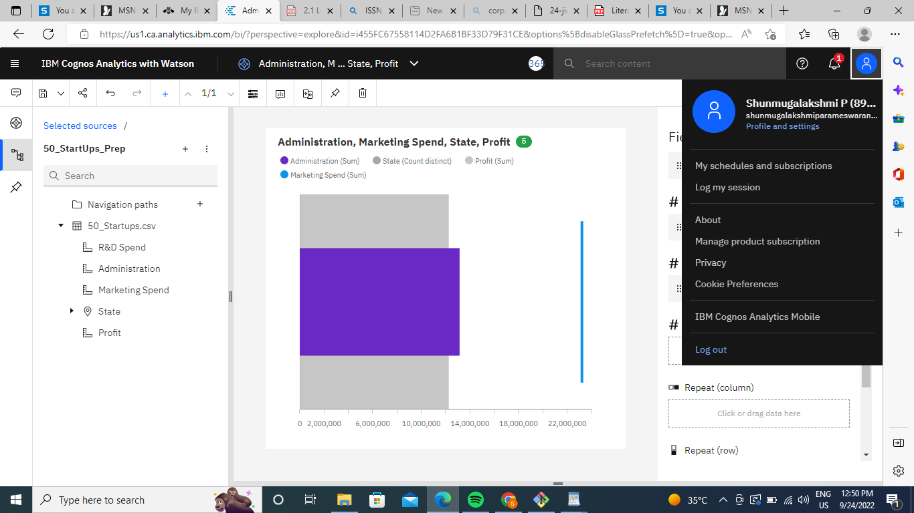  
  
<https://us1.ca.analytics.ibm.com/bi/?perspective=explore&pathRef=.my_folders%2FAdministration%252C%2BMarketing%2BSpend%252C%2BState%252C%2BProfit&subView=model000001836e57231c_00000000>   
  
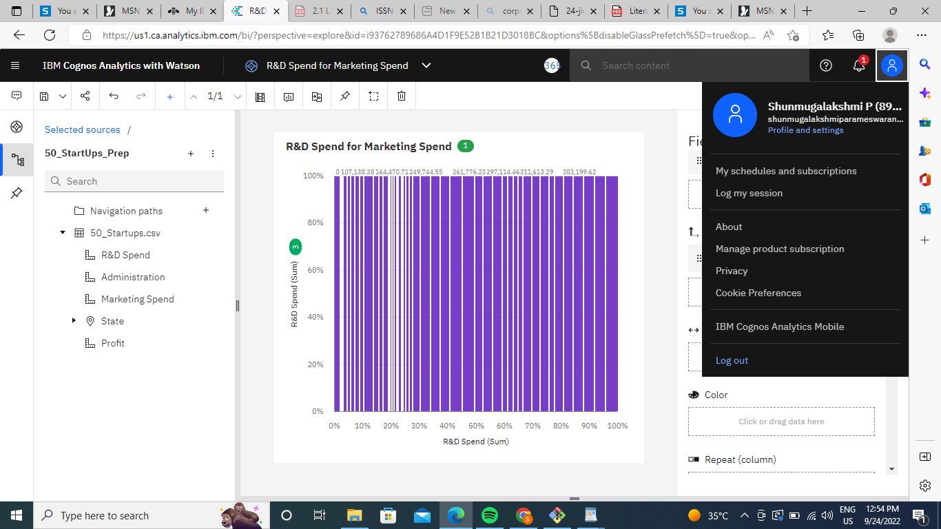  
  
<https://us1.ca.analytics.ibm.com/bi/?perspective=explore&pathRef=.my_folders%2FR%2526D%2BSpend%2Bfor%2BMarketing%2BSpend&subView=model000001836e57231c_00000000>